REST APIS
GET REQUEST
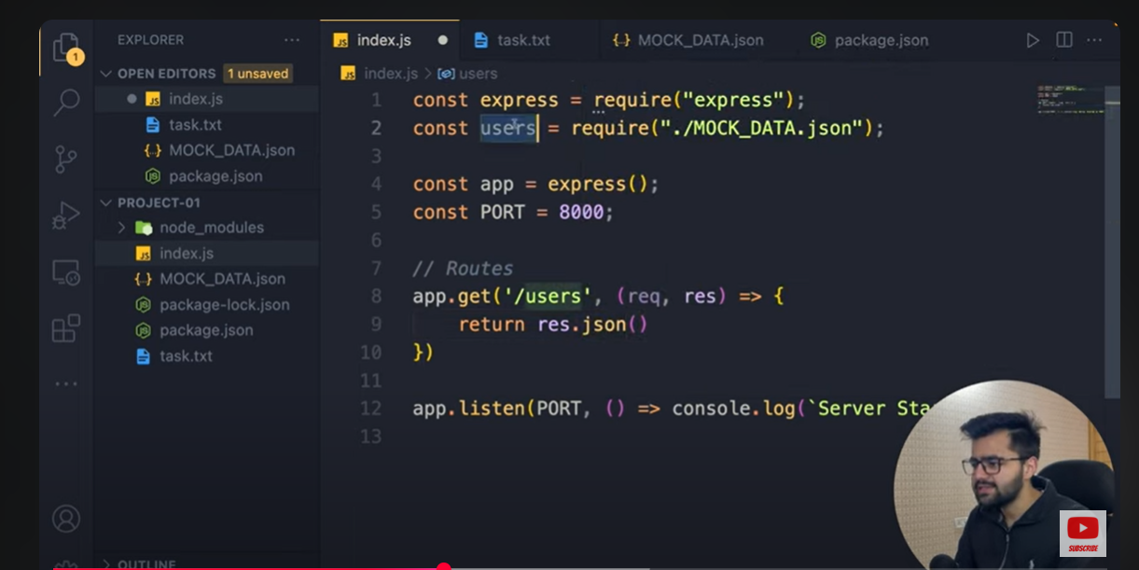
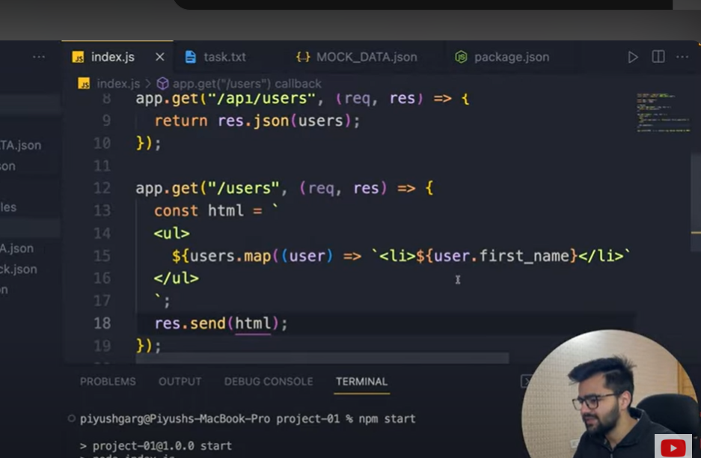

GETIING UER WITH SPECIFI ID
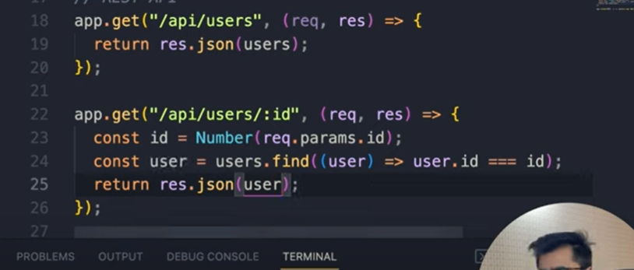
POST PUT PATCH
POST PUT PTACH KAI LIYE BROWSER SAI KOI WAY NHI HAI KAI HAM ISAY TEST KRAI KR SAKAY IS KAI LIYE HAM POSTMAN INSTALL KRTAY HAI

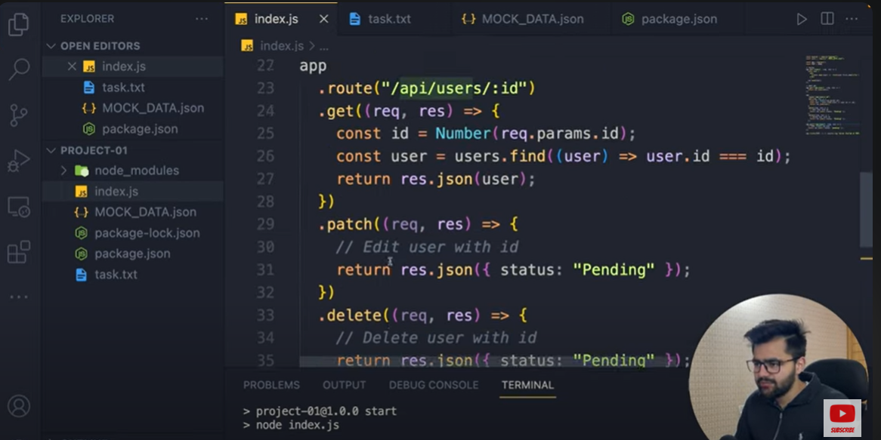

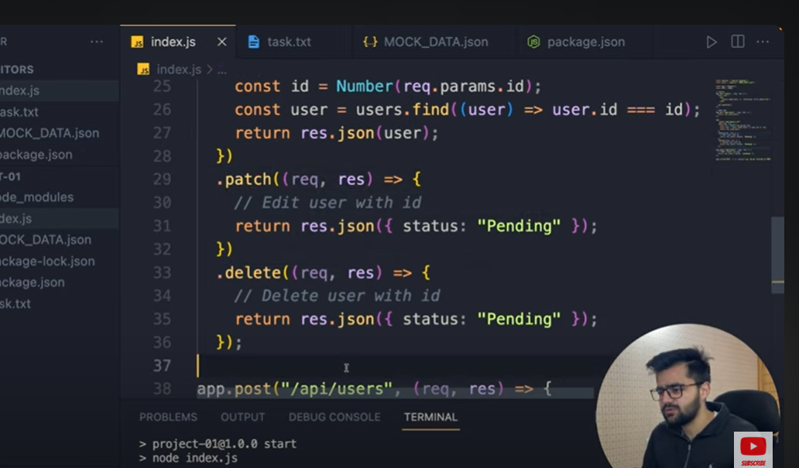

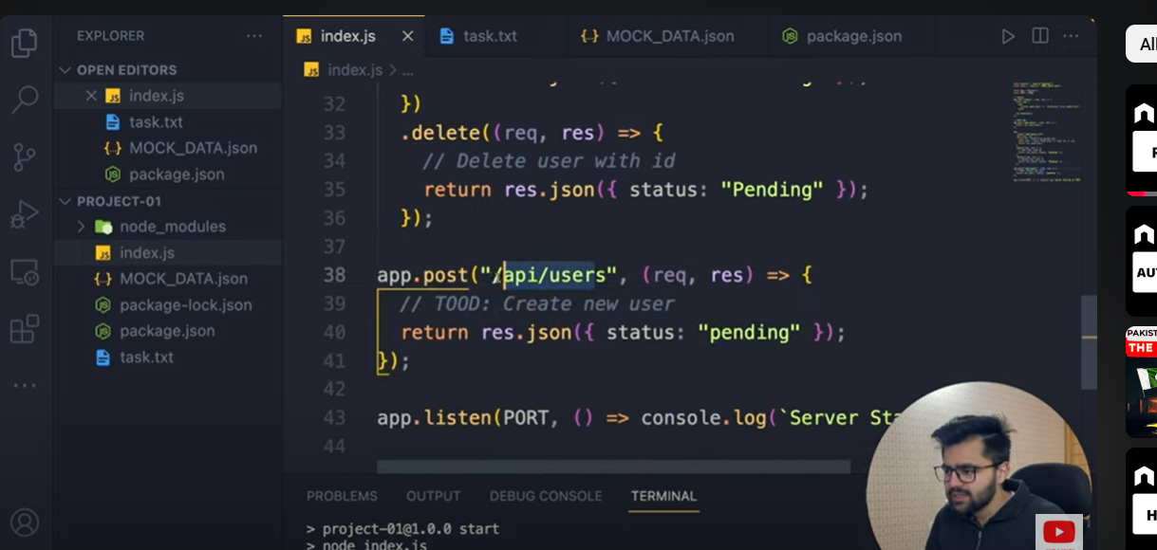

POST API MIDDLEWARE IS NECESSARY FO THIS OTHER THE MSG DIPLAY UNDEFUNED
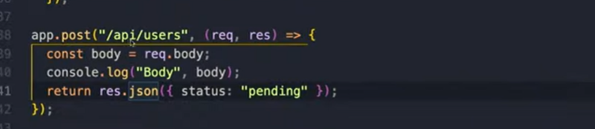
MIDDLE WARE TO GET THE FULL BODY CONTENT
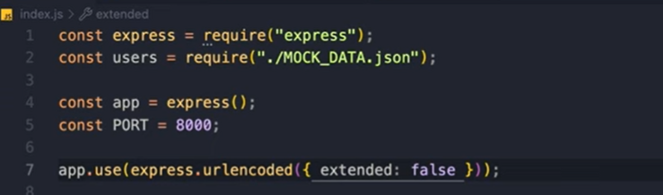

ADD DATA TO THE FILE
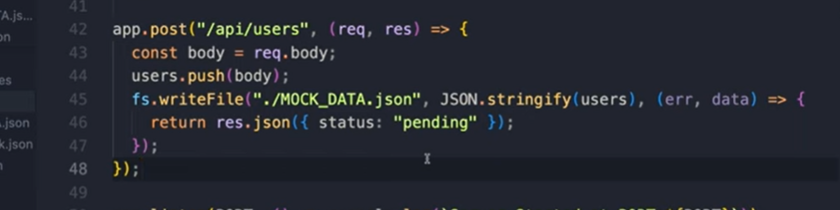

PATCH
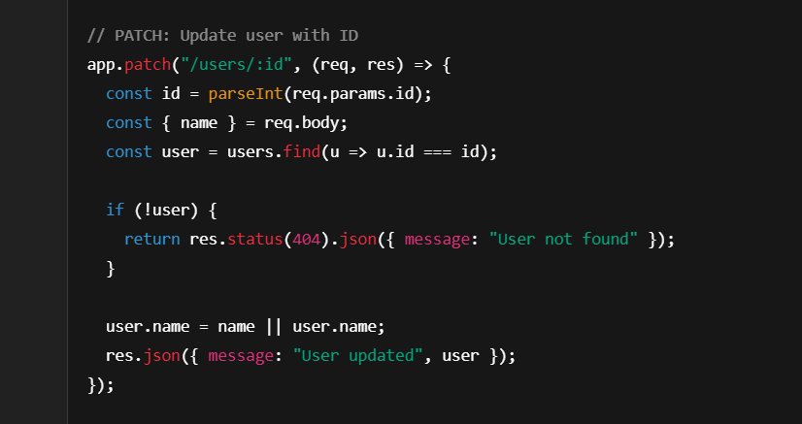

DELETE
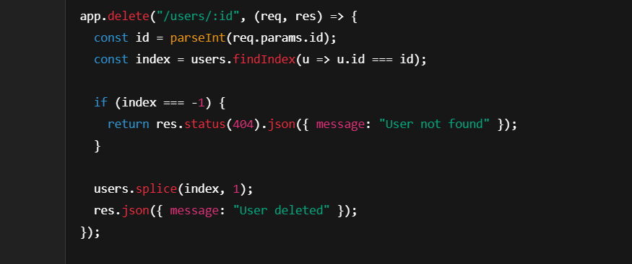

MIDDLE WARE
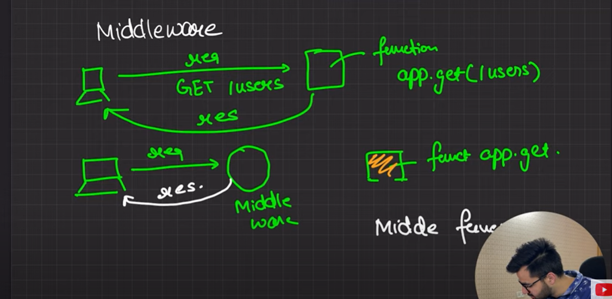
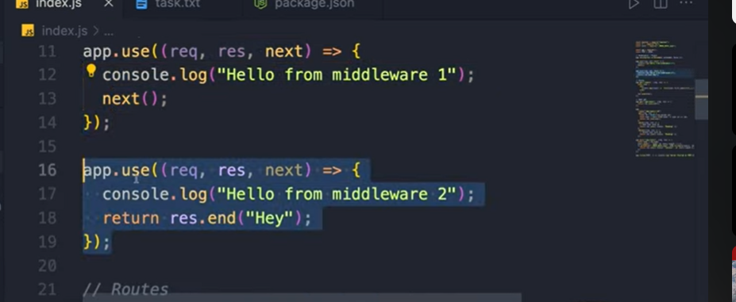

MIDDLE WARE

const express = require("express");
const app = express();

// Middleware: Check if the request has a valid token
const authMiddleware = (req, res, next) => {
const token = req.headers["authorization"]; // Read token from header

if (token === "Bearer mysecrettoken") {
// If token is valid
next(); // Proceed to next route handler
} else {
res.status(401).json({ message: "Unauthorized: Invalid token" });
}
};

// Public route (no auth needed)
app.get("/public", (req, res) => {
res.send("This is a public route");
});

// Protected route (auth needed)
app.get("/private", authMiddleware, (req, res) => {
res.send("This is a protected route");
});

// Start server
app.listen(3000, () => {
console.log("Server is running on http://localhost:3000");
});

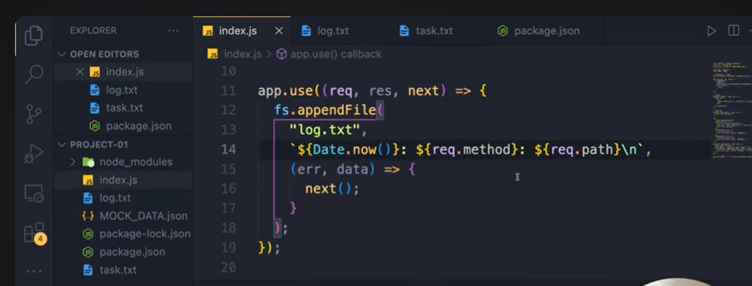

INCLUDE HEADERS
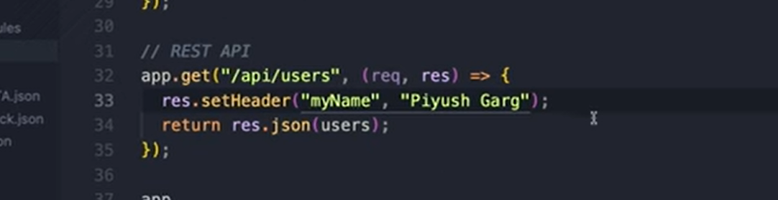

CUSTOM HEADER
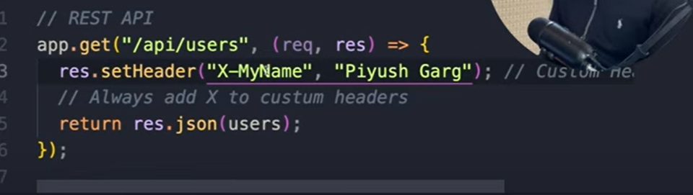

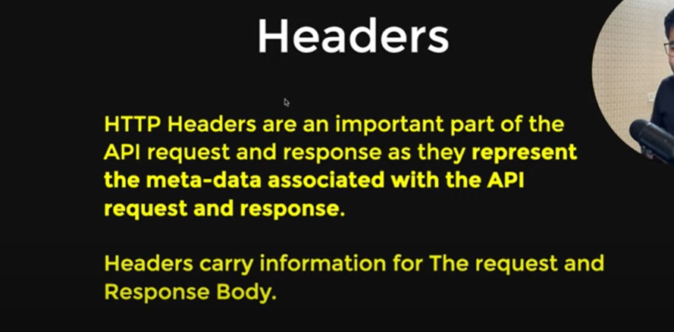

Responses
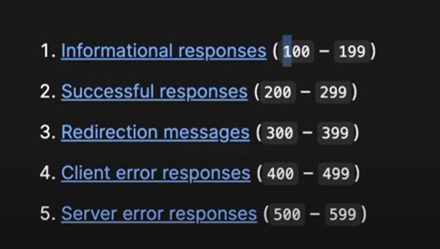

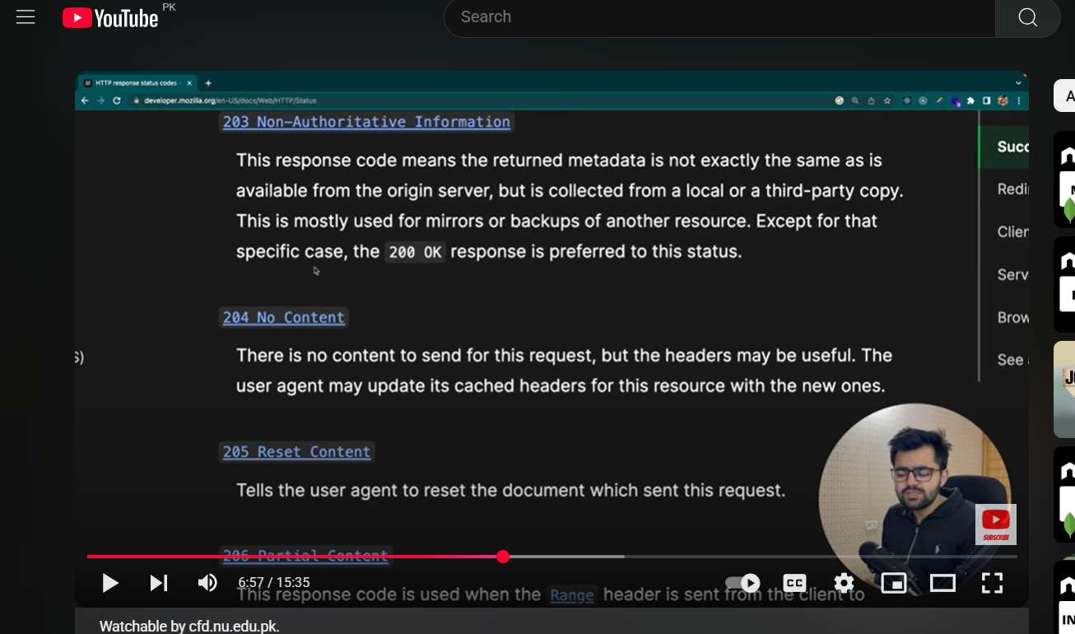

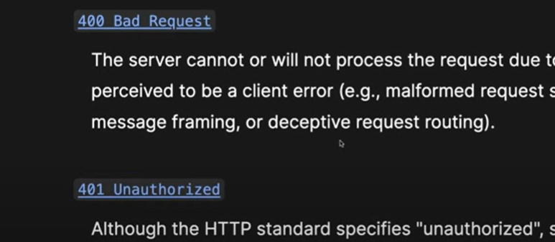

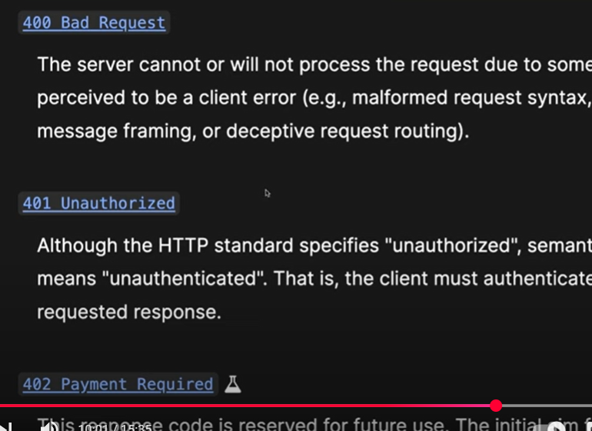

Mongo
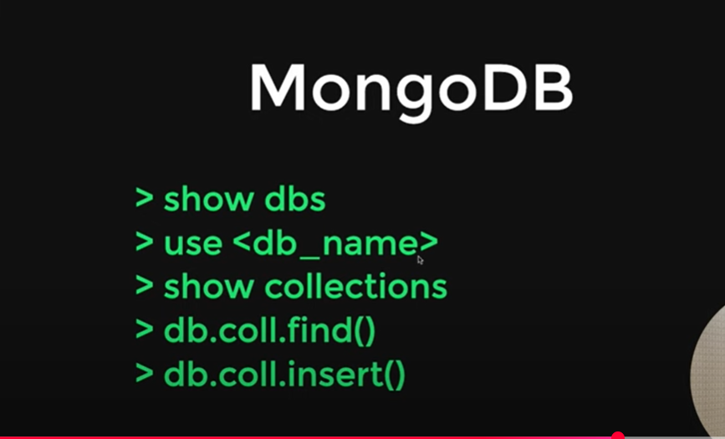

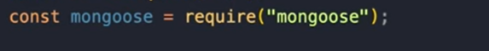
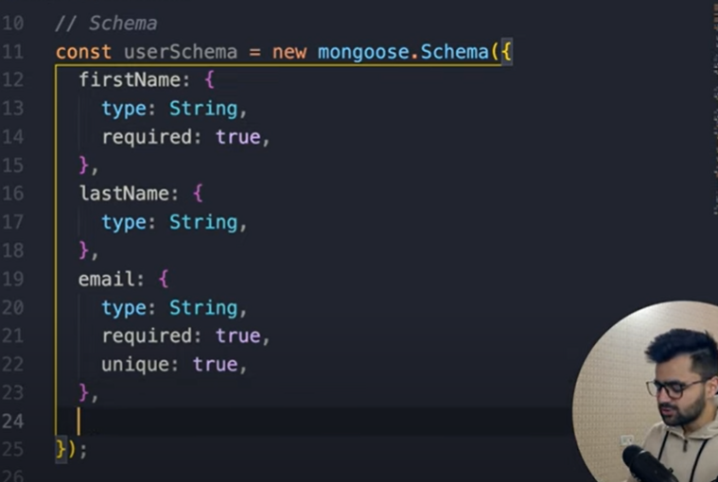
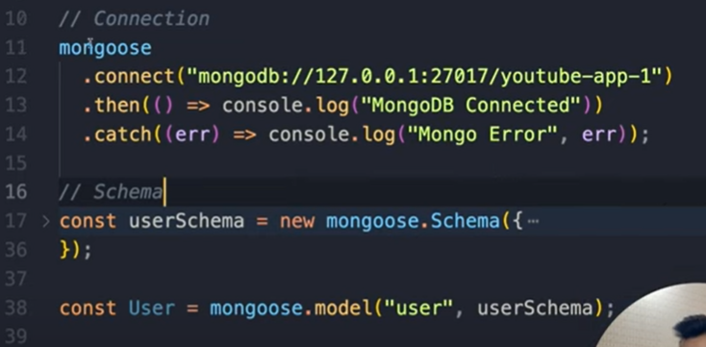
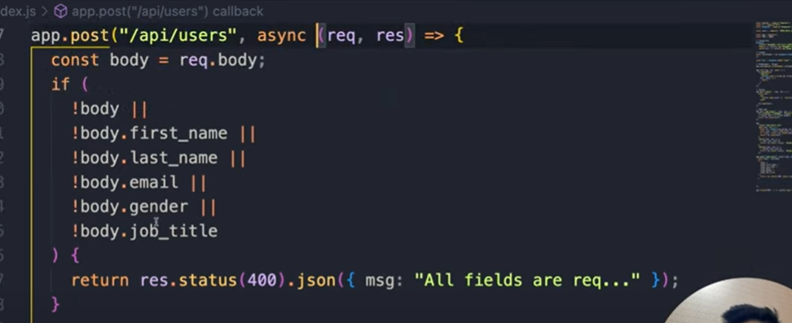
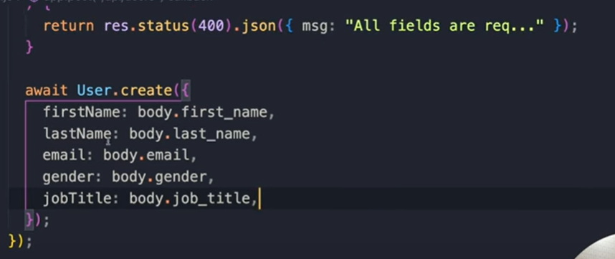
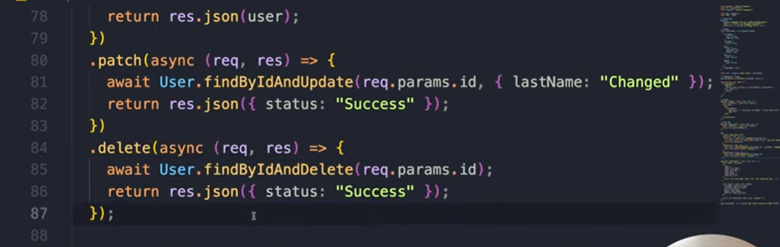

Authentication

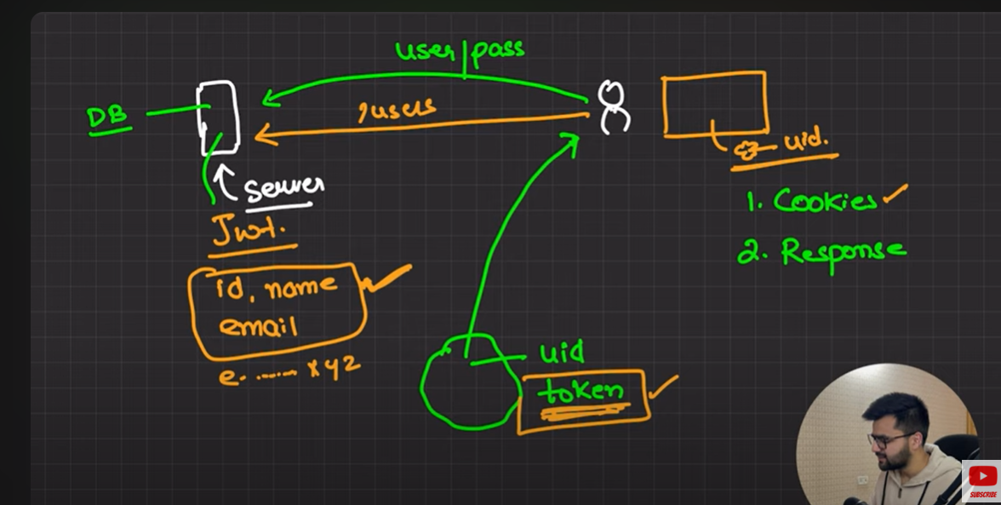

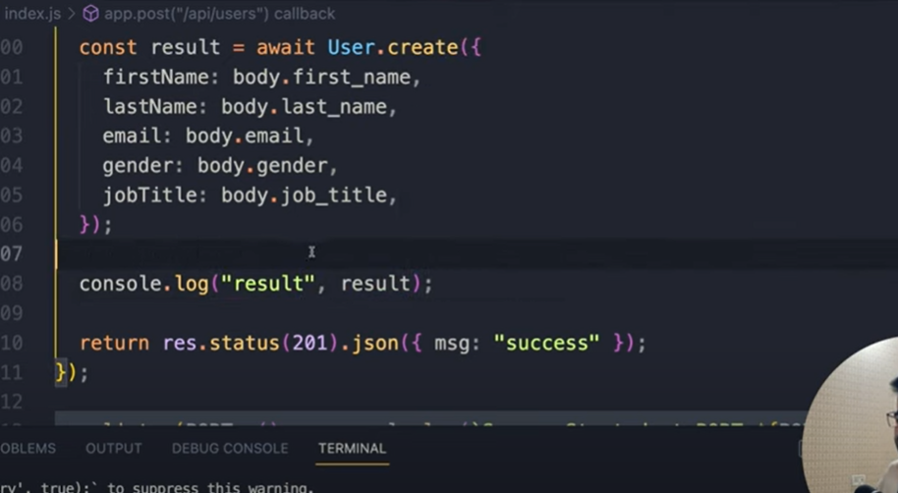
Now fetching data frpm mpngp db

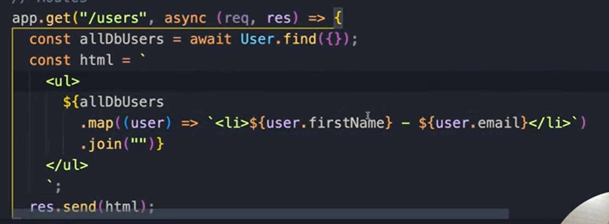
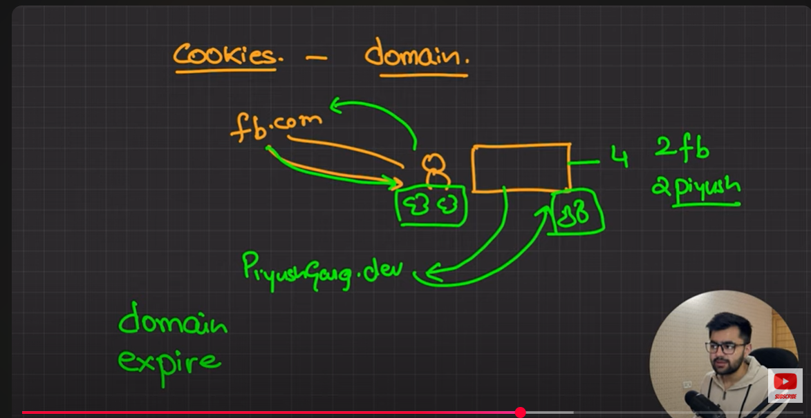

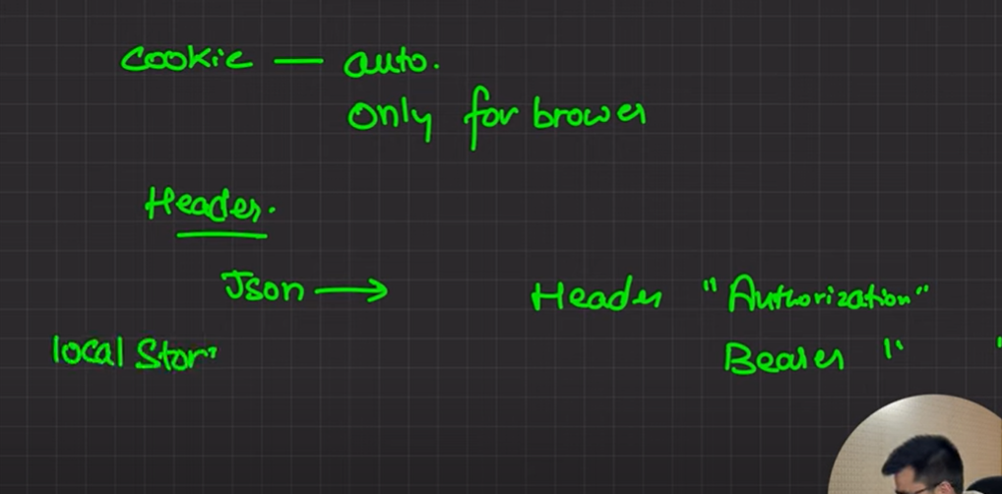

Authentication
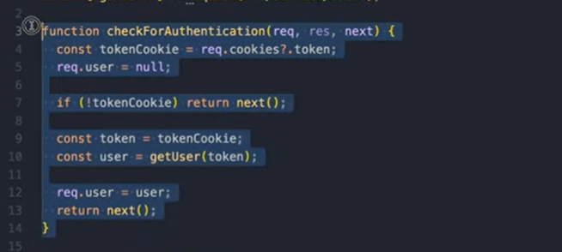
Authorization
